TRANSLATOR

INSTALLATION DOCUMENT

**UPLOADING THE SOURCE CODE PACKAGE**

* Unzip the contents of the Source Code Zip package in a new folder, for example, let’s call it **TRANSLATOR.**

*Assuming you want to install it under the root domain.*

## Install Apache:

Our next step is to install Apache. Type the following commands in the terminal:

**sudo apt-get update**

**sudo apt-get install apache2**

**cd /etc/apache2**

**sudo chmod –R 777 .**

**sudo service apache2 restart**

**Install Mysql:**

**sudo apt-get install mysql-server**

**You will be prompted with a (Y/n). Type y and press Enter.**

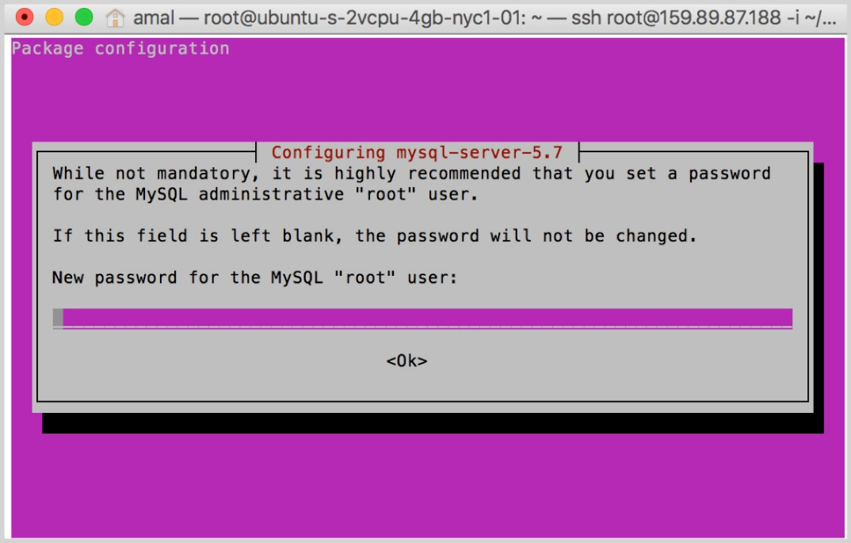

**sudo nano /etc/mysql/mysql.conf.d/mysqld.cnf**

Change the bind-address from the default value of **127.0.0.1** to **0.0.0.0**

**bind-address    =   0.0.0.0**

**sudo service mysql restart**

**sudo service mysql restart**

**sudo service apache2 restart**

**Install Php:**

**sudo apt-get install php7.0 libapache2-mod-php php-mcrypt php-mysql php-gd php-bcmath**

**Change the location of index.php**

**sudo nano /etc/apache2/mods-enabled/dir.conf**

Inside of the file will look like this:

**DirectoryIndex index.html index.cgi index.pl index.php index.xhtml index.htm**

We want to move the index.php file above to the first position after the DirectoryIndex, like this:

**DirectoryIndex index.php index.html index.cgi index.pl index.xhtml index.htm**

**Enable Short_Open_tags:**

**sudo nano /etc/php/7.0/apache2/php.ini**

Scroll down and search for a line with text "**short_open_tags = off**" and change the status from "**off**" to "**on**".

**short_open_tags = on**

Scroll down and search for a line with text "**upload_max_filesize = 2M**" and change "**2M**" to "**20M**".

**sudo service apache2 restart**

**1. Install phpMyAdmin**

Enter the following command to install phpMyAdmin.

**sudo apt-get install phpmyadmin apache2-utils**

You will be prompted with a (Y/n). Type y and press Enter.

### https://helptier.s3.amazonaws.com/article/bitexchange/mrMzgHsxuudf4pyxxIHukGdREsmpqfboO1X4V5Rs.png

**Click ENTER**

### https://helptier.s3.amazonaws.com/article/bitexchange/4hapZW8xXIyL9p7UHCBvitpEtfZXEdIKlLJHEnql.png

**Click ENTER**

### You will be prompted to enter a password for phpMyAdmin. Enter the same password which you have used during mysql installation in Step: 3 and press Enter. Save this password.

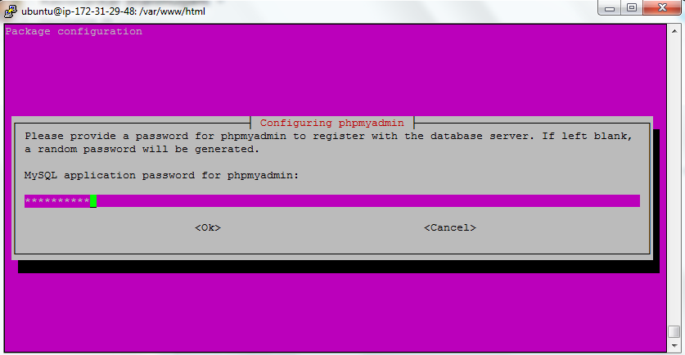

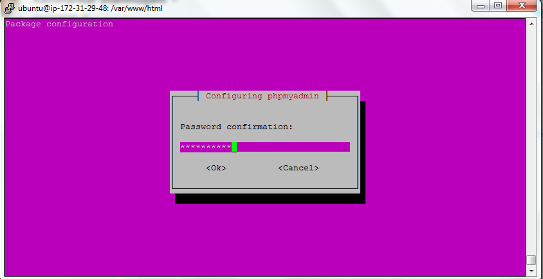

**sudo echo 'Include /etc/phpmyadmin/apache.conf' >> /etc/apache2/apache2.conf**

**sudo service apache2 restart**

n). pe y and press Enter.

## Login to phpmyadmin:

If you have pointed your exchange to a domain name: https://domain_name/phpmyadmin

If you have pointed your exchange to a ip address: <http://ip_address/phpmyadmin>

**Upload translator.sql file taken from**

**cd var/www/html/translator**

**Install Cli:**

**sudo apt-get install php-cli php-curl curl**

**Install Composer:**

**curl -sS https://getcomposer.org/installer | sudo php -- --install-dir=/usr/local/bin --filename=composer**

Now, use an FTP program such as FileZilla to upload the contents of the **translator** folder under the **/var/www/html/**  public folder.

Now navigate to the **/var/www/html/translator** folder in terminal and update the laravel dependencies, run the following command

**sudo composer update**

Or if above command at end gives error then try,

**sudo composer update --no-scripts**

*give 777 permission for **storage** and **bootstrap** folder

* give 755 permission to the project folder(**translator** folder)

Open the .env file under:

***/* translator*/.env***

[Change the DB connection settings]

Now to run the app from browser, you need to point you {server-ip} to **/var/www/html/translator/public** folder, to do this follow this steps

**DocumentRoot /var/www/html** >> change this to **DocumentRoot /var/www/html/translator/public**

In /etc/apache2/apache2.conf edit

**nano /etc/apache2/apache2.conf**

<Directory /var/www/>

Options Indexes FollowSymLinks

**AllowOverride None**

Require all granted

</Directory>

Change AllowOverride None >>**AllowOverride All**

Now restart the apache2 server, run following command :

**sudo apache2 reload**

**sudo apache2 restart**

**\*now you can navigate you browser with {server-ip} to check website is working or not .**